Comparing and Contrasting

Name: Katelyn Rosevear Time Allotted: 45 minutes
Grade Level: 3rd Subject: Writing
Materials Required:
- Allard, H., & Marshall, J. (1977). Miss Nelson is missing! Boston: Houghton Mifflin. (one copy per student)
- Pictures of a cheetah and a leopard
- Venn Diagrams
- Writing graphic organizers

Common Core State Standard
CCSS.ELA-Literacy.W.3.2b Develop the topic with facts, definitions, and details.

Objective(s): A specific, measurable portion of a GLCE or HSCE (may more clearly state with Bloom’s taxonomy verb) including the level of proficiency

The student will develop the topic of compare and contrast essay with supporting details. (Synthesis)

Assessment:
Informal Formative- Student Think-Pair-Share with a partner, discussion one comparison and one contrast between the character Miss Nelson and Miss Swamp. Teacher should use students’ responses as a check for understanding.

Formal Summative- Using the completed graphic organizer, students will craft a compare and contrast essay of the characters Miss Nelson and Miss Swamp. The essay should have an introduction, an explanation of the contrasts of each character (one paragraph each) with 3 supporting details, an explanation of the comparisons (one paragraph) with 3 supporting details, and a conclusion.

Instructional Procedure: What information do students need to accomplish the objective?

- Anticipatory Set:
  - Show the class a picture of a cheetah and a leopard.
  - Ask, “How are these to animals the same? How are they different?”
  - Today we are going to be looking at the ways two different things are the same (compare) and how they are different (contrast).
- State Purpose and Objective of Lesson:
  - We will be comparing and contrasting two different objects of people and determining the ways the contrast and the ways they compare.
  - When we determine these comparisons and contrasts we will be able to use this information as details to support our writing.

- Instructional Input/Direct Instruction:
  - Define compare and contrast
    - Compare means to see how two or more things are alike or the same.
    - Contrast means to look at how things are different or not alike.

- Modeling:
  - Strategy 3.4 Venn Diagram
On the board, create a Venn Diagram comparing and contrasting Summer and Winter, with the similarities (comparisons) in the overlapping portion of the diagram and differences (contrasts) in the outer sections of the diagram. Teacher will list a unique characteristic of each and one similarity.
    - Summer- hot weather (contrast)
    - Winter- cold weather (contrast)
    - Both- have holidays (comparison)

- Guided Practice:
  - Have students think of more comparisons and contrasts between Summer and Winter and add those ideas to the Venn Diagram.
  - Strategy 2.5 Paired Reading
Students read Miss Nelson is Missing with a reading partner. As they read, students can ask their partner questions for clarification.
  - Strategy 1.1 Think-Pair-Share
Ask, “What is one way Miss Nelson and Miss Swamp are different and one way they are similar?” Students have 30 seconds to think of an answer. Then students pair up with a partner and each shares their answer. Allow 2 minutes for discussion, followed by 2 or 3 groups sharing their answers.
  - Have students fill in a Venn Diagram comparing and contrasting Miss Nelson and Miss Swamp. Students will share ideas with a their partner.
  - “These ideas of comparing and contrasting can be used as reasons to support and opinion in writing. In this case there are two opinions- first Miss Nelson and Miss Swamp are different, they are contrasting; second Miss Nelson and Miss Swamp are similar (comparison). We can use these ideas to help us write an essay comparing and contrasting these two characters.”
  - Together begin to take the ideas from the Venn Diagram and fill in a graphic organizer. Idea 1 should be the ways Miss Nelson is different from Miss Swamp (contrast) and students should provide 3 supporting details/reasons (from Venn Diagram). Idea 2 should be the ways Miss Swamp is different from Miss Nelson (contrast) and students should provide 3 supporting details/reasons. Idea 3 should be the ways Miss Nelson and Miss Swamp are similar (comparison) and students should provide 3 supporting details/reasons.
- Independent Practice:
Students will write a short essay using their Venn Diagrams comparing and contrasting the characters of Miss Nelson and Miss Swamp.

- Differentiated Consideration
- If necessary students may use only 2 supporting details instead of three for each main idea.
- Need different modes of learning or learn through a different multiple intelligence strategies than what was delivered.

- Closure:
  - Review the objective
  - Give me a thumbs-up if you know the difference between a comparison and a contrast.
  - Now that you know how to compare and contrast two different things you will be able to use this strategy in other areas of your writing, such as compare/contrast of two ideas in Science or two different people in Social Studies.

- References:
Allard, H., & Marshall, J. (1977). Miss Nelson is missing!. Boston: Houghton Mifflin.

Explanation of Identified Instructional Strategies

1.1 Think-Pair Share
- This strategy allows students to collaborate ideas and learn from one another. In this lesson students will be compiling a list of comparisons and contrasts between two characters. Sharing ideas will allow students to expand their thinking and lead to a richer understanding.
- This strategy is quick, yet effective. Unlike other strategies, it does not take much time, but it will allow students to collaborate with one another and firm up their understand, which is the purpose of using such a strategy.
- When using this strategy it is important for students to first fully develop their own thoughts and ideas, otherwise students may only take the ideas of others. To avoid this, have students jot down some of their ideas before sharing to ensure each student has given thought to the question/prompt.
2.5 Paired Reading
- This strategy was selected as it provides students with reading support. Some of the lower-level readers may find the text challenging, but with the added support of a partner, students should be able to read through the text with understanding.
- Using this strategy is beneficial because it allows students to work together as they read the text. This allows students to confer with their partner and receive clarification if needed. As a bonus it also can increase students’ reading fluency.
- A problem could occur is a student’s reading level is severely low. If the text is at a student’s frustration level. Differentiation may be required for this student, as they may require their partner to read the text, as they follow along.
3.4 Venn Diagrams
- Venn Diagrams provide a visual representation of comparisons and contrasts between two different people or things. As this lesson is focusing on comparing and contrasting two characters, Venn Diagrams are helping in providing a nonlinguistic representation of the information.
- This strategy works well over others, because it clearly labels and separates similarities and differences.
- I cannot think of any issues preventing the use of the strategy, as long as the teacher directly models how to use and label a Venn Diagram.
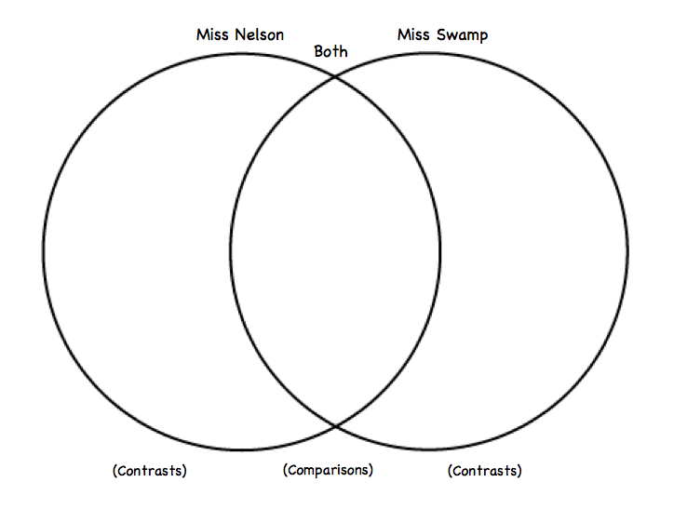
Writing Graphic Organizer
