Exploring the Surface of the Earth
Third Grade-Science
By Katelyn Rosevear

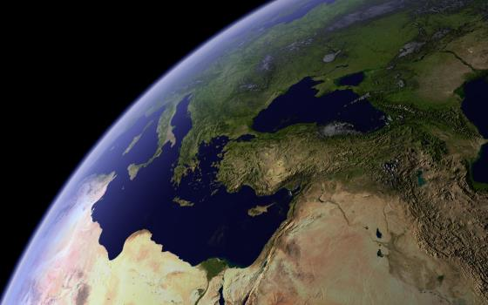
(http://hdw.eweb4.com/out/129525.html )
Exploring Earth Materials Part 1

Name: Katelyn Rosevear Time Allotted: 60 min
Grade Level: 3rd Subject: Science
Materials Required:
- Sample of a mineral
- Sample of sand
- Sample of soil
- Sample of water
- Whiteboards (one per student)
- Whiteboard marker
- Earth’s Material Discover Journal

Michigan Content Expectations

E.SE.03.13 Recognize and describe different types of Earth materials (mineral, rock, clay, boulder, gravel, sand, soil, water, and air).

Objective(s):
The student will recognize different types of Earth materials (mineral, sand, soil, water) by correctly labeling 3/4 materials correctly. (Knowledge)

The student will describe different types of Earth materials (mineral, sand, soil, water) by correctly giving a description of 3 of the 4 materials. (Comprehension)

Student Friendly Objective(s):
The student will recognize different types of Earth materials (mineral, sand, soil, water). (Knowledge)

The student will describe different types of Earth materials (mineral, sand, soil, water). (Comprehension)

Assessment:
Objective 1 Assessment: Pictures of each of the earth materials will be displayed. Students will write the name of the material that is shown on their personal whiteboard. Students will hold up their whiteboard with their answer so the teacher is able to view all of the answers. (Informal Formative)

Objective 1 Assessment: Students will visit four centers, one for each of the Earth materials covered. At each center, students will fill in the square on their Earth’s Material Discovery Notes. For each material student will draw a picture and label as the correct Earth material. Students need to draw and label at least 3 out of 4 of the Earth’s materials correctly in order to reach proficiency. (Formal Formative)

Objective 2 Assessment: Students will be read a definition of the individual earth materials and will write the corresponding earth material on their whiteboard. Students will hold up their whiteboard with their answer so the teacher is able to view all of the answers. (Informal Formative)

Objective 2 Assessment: Once students have completed the first half of their Earth’s Material Discovery Notes and reviewed the answers at a class, they will complete the worksheet by writing a short description for each Earth material. In order to show mastery, students should right a valid description of at least 3 out of 4 Earth’s materials. (Formal Formative)

Objective 1 and 2 Assessment:
Unit test- students will score an 80% or higher on the test to show they have reached the learning targets. (Formal Summative)

Instructional Procedure:

Anticipatory Set:
  - Show class samples of different Earth materials and ask students what could be built with these materials. Explain our Earth is made up of all of these materials. Have students give examples of places around the state where they have seen those Earth materials.
  - Previously you have learned about our Earth and its environment. Today we are going to take a closer look at the materials that make up the Earth.
  - We are going to look at half of the different Earth materials today and the other half we will study tomorrow.
  - Remember to follow our classroom procedures and act as model students- listen respectfully, participate in learning, and give your best effort.
State Purpose and Objective of Lesson:
  - Post student friendly objectives and read aloud as a class.
  - It is important for you to know what the Earth is made off, in order for us to take a look at the specific Earth materials that we find in Michigan.
Instructional Input/Direct Instruction:
  - “The earth is made up of several different materials. Can you think of any? When we explore our Earth, we find many materials including minerals, rocks, clay, boulders, gravel, sand, soil, water, and air. Today we are going to be scientists and take a closer look at minerals, sand, soil, and water.”
  - “A mineral is inorganic, which means it is not made by a living organism, but it is made by nature. It is almost always a solid and has a predictable pattern.” (Kids Love Rocks, n.d.)
  - “You might have made a sand castle at the beach or in a sandbox. Sand is made up of ‘small particles of various minerals and broken rocks, the result of weathering and erosion’” (Wilson, 2013).
  - “Soil is similar to dirt. Soil is made of loose, weathered rock and organic material in which plants with roots can grow” (Wilson, 2013).
  - “Water is a liquid found all over the earth that is needed for life.” (Wilson, 2013)
Modeling:
  - Show picture of a mineral.
  - “This is an earth material and I want to figure out what which material it is. I can look at the picture for clues. I see that this is a solid material and that it had a pattern. That clues me in that it is a mineral.”
Guided Practice:
  - Show students images of each of the four earth materials and have them record their answers on personal whiteboards.
  - Next read definitions of the minerals and have students write down the matching earth material on their whiteboard.
    - Mineral- A solid material made up of complex patterns
    - Sand- A material made up of small rock and mineral particles
    - Soil- A material made of rock particles and organic material
    - Water- A liquid material necessary for life survival
Independent Practice:
  - Students will rotate in small groups to each of the four centers. There is one center for each of the four Earth materials covered in the lesson (mineral, sand, soil, and water). At each center, there will be a sample of each material for students to examine. Students will visit each center, draw a picture of the sample and label it as mineral, sand, soil, or water. Students should spend approximately 10 minutes at each center.
  - After students have drawn and labeled each material, the class will gather back together and discuss each center and the student’s answers.
  - Students will then write a short description of each material.
  - Have students share a few descriptions with the whole class.

Differentiated Consideration:
- Students who finish early can play this game to review the different earth materials. http://www.fossweb.com/modulesK-2/PebblesSandandSilt/activities/ findearthmaterials.html
- Students who have difficultly writing a description can give an oral description of the Earth Materials.

Multiple Intelligences:
- Logical-mathematical: Students can create a hypothesis for ways, which each Earth material can be used.
- Spatial: Students are drawing a picture of each material.
- Linguistic: Students can write a journal entry, describing each of the earth materials.
- Bodily-kinesthetic: Students are working on hands-on exploration in the Earth Material Centers.
- Musical: Students can create a song or rap to help them remember the earth materials.
- Intrapersonal: Students can discuss their findings with a partner.

Closure:
  - “Give me a thumbs up if you think you have met our first objective and a thumbs down if you still have questions. What about our second objective?”
  - “Tell me one of the earth materials we studied today and describe it to me.”
  - Today when you go out for recess see if you can spot any of the earth materials that we examined in class.

References:
- Kids Love Rocks. (n.d.). What is a Mineral. Kids Love Rocks. Retrieved March 30, 2013, from http://www.kidsloverocks.com/html/mineral.html
- Wilson. (2013). GB Wilson 3rd Grade Earth Materials flashcards. Quizlet. Retrieved March 30, 2013, from http://quizlet.com/9012813/gb-wilson-3rd-grade- earth-materials-flash-cards/

Earth’s Materials Discovery Journal

1 | 2
Description: | Description:
3 | 4
Description: | Description:
Exploring Earth Materials Part 2

Name: Katelyn Rosevear Time Allotted: 60 min
Grade Level: 3rd Subject: Science
Materials Required:
- Sample of rock
- Sample of clay
- Sample of boulder
- Sample of gravel
- Whiteboard
- Whiteboard marker
- Earth’s Materials Discovery Journal

Michigan Content Expectations (GLCE, Common Core State Standard or Next Generation Science Standard written out)

E.SE.03.13 Recognize and describe different types of Earth materials (mineral, rock, clay, boulder, gravel, sand, soil, water, and air).

Objective(s):
The student will recognize different types of Earth materials (rock, clay, boulder, gravel) by correctly labeling 3/4 materials correctly. (Knowledge)

The student will describe different types of Earth materials (rock, clay boulder, gravel) by correctly giving a description of 3 of the 4 materials. (Comprehension)

The student will write an informational paragraph on the eight Earth Materials (discovered in Exploring Earth’s Materials pt.1 and 2) by including each of the eight materials along with a description of each. (Synthesis)

Student Friendly Objectives:
I can recognize different types of Earth materials (rock, clay, boulder, gravel). (Knowledge)

I can describe different types of Earth materials (rock, clay boulder, gravel). (Comprehension)

Assessment:

Objective 1 Assessment:
Pictures of each of the earth materials will be displayed. Students will write the name of the material that is shown on their personal whiteboard. Students will hold up their whiteboard with their answer so the teacher is able to view all of the answers. (Informal Formative)

Objective 1 Assessment:
Students will visit four centers, one for each of the Earth materials covered. At each center, students will fill in the square on their Earth’s Material Discovery Lab write-up. For each material student will draw a picture and label as the correct Earth material. Students need to draw and label at least 3 out of 4 of the Earth’s materials correctly in order to reach proficiency. (Formal Formative)

Objective 2 Assessment:
Students will be read a definition of the individual earth materials and will write the corresponding earth material on their whiteboard. Students will hold up their whiteboard with their answer so the teacher is able to view all of the answers. (Informal Formative)

Objective 2 Assessment:
Once students have completed the first half of their Earth’s Material Discovery Lab and reviewed the answers at a class, they will complete the worksheet by writing a short description for each Earth material. In order to show mastery, students should right a valid description of at least 3 out of 4 Earth’s materials. (Formal Formative)

Objective 1 and 2 Assessment:
Unit test- students will score an 80% or higher on the test to show they have reached the learning targets. (Formal Summative)

Instructional Procedure:

Anticipatory Set:
  - Show class pictures of natural wonders from Michigan creating by Earth materials (Sand dunes, Pictured Rocks) (http://cache.marriott.com/propertyimages/t/tvcfi/phototour/tvcfi_phototour14.jpg?Log=1)
(http://knoji.com/images/user/800px-Pictured_Rocks_-_Grand_portal(1).jpg)
  - Yesterday, we learned about four of the Earth’s natural materials and now we are going to take a deeper look at four more Earth materials.
  - “We are going to practice being scientists and study rocks, clay, boulders, and gravel.”
  - Remind students to follow our classroom procedures and act as model students- listen respectfully, participate in learning, and give best effort.
State Purpose and Objective of Lesson:
  - Post student friendly objectives and read aloud as a class.
  - It is important for you to know what the Earth is made off, in order for us to take a look at the specific Earth materials that we find in Michigan.

Instructional Input/Direct Instruction:
  - “We have already explored four of the materials that make up the Earth- minerals, sand, soil, and water. Today we are going to take a closer look at rocks, clay, boulders, and gravel.”
  - “Rock is an earth material found in the earth’s crust made up of two for more minerals” (How Rocks Are Formed, n.d.).
  - “Clay is the finest type of soil with particles that are 0.002 mm in diameter” (Wilson, 2013.).
  - “Boulders are large rocks, bigger than the size of your head.”
  - “Gravel is made up of rock fragments and pebbles” (Wilson, 2013).
  - Ask students “If I have an earth material that is made up of two of more minerals, which material do I have? What if I have large rock that is the size of my desk- what earth material would that be?”
  - Students pair share answers.
Modeling:
  - Show a picture of a rock.
  - “I want to try to determine what kind of earth material this is. Looking at this image, I can see that this material is made up of several different substances, which look like minerals to me because they have a pattern. I know that rocks are made up of two or more minerals, so I know that this is a rock.”
Guided Practice:
  - Show students images of each of the four earth materials and have them record their answers on personal whiteboards.
  - Next read definitions of the minerals and have students write down the matching earth material on their whiteboard.
    - Rock- A material found in the earth’s crust, made up of two or more minerals
    - Clay- A material made up of the smallest rock particles (finer than sand)
    - Boulder- A large rock, bigger than 10 inches in diameter
    - Gravel- A material made up of rock fragments (coarser than sand)

Independent Practice:
  - Students will rotate in small groups to each of the four centers. There is one center for each of the four Earth materials covered in the lesson (rock, clay, boulder, gravel). At each center, there will be a sample of each material for students to examine. Students will visit each center, draw a picture of the sample and label it as mineral, sand, soil, or water. Students should spend approximately 10 minutes at each center.
  - After students have drawn and labeled each material, the class will gather back together and discuss each center and the student’s answers.
  - Students will then write a short description of each material.
  - Have students share a few descriptions with the whole class.

Differentiated Consideration (Adjust instruction, tools, resources or activities for students who):
- Struggling students can give an oral description of materials. They may also match a pre-written description with each of the four materials.
- Students who finish early can play an Earth’s materials Jeopardy game. http://www.superteachertools.com/jeopardy/usergames/May201019/game1273507997.php (Super Teacher Tools, n.d.)
Multiple Intelligences
Logical-mathematical: Students can create a hypothesis for ways, which each Earth material can be used.
Spatial: Students are drawing a picture of each material.
Linguistic: Students can write a journal entry, describing each of the earth materials.
Bodily-kinesthetic: Students are working on hands-on exploration in the Earth Material Centers.
Musical: Students can create a song or rap to help them remember the earth materials.
Intrapersonal: Students can discuss their findings with a partner.

Closure:
  - “Looking back at our objectives give me a thumbs up if you think you reached today’s objectives and a thumbs down if you still are confused or have more questions.”
  - As a ticket out the door, have students write down one of the four Earth materials studied in this lesson along with an example of where it can be found.
  - Earth materials are the natural materials found in our world so it should be no surprise to find them all around you. See how many different Earth materials you can spot today.

References:
How Rocks Are Formed. (n.d.). Rocks For Kids. Retrieved March 31, 2013, from http://www.rocksforkids.com/RFK/howrocks.html
Super Teacher Tools. (n.d.). earth materials Jeopardy Review Game. Super Teacher Tools. Retrieved March 31, 2013, from http://www.superteachertools.com/jeopardy/usergames/ May201019/game1273507997.php

Wilson. (2013). GB Wilson 3rd Grade Earth Materials flashcards. Quizlet. Retrieved March 30, 2013, from http://quizlet.com/9012813/gb- wilson-3rd-grade-earth-materials-flash-cards/

Earth’s Materials Discovery Lab

1 | 2
Description: | Description:
3 | 4
Description: | Description:

Erosion

Name: Katelyn Rosevear and Ashley Cleveland Time Allotted: 45 minutes
Grade Level: 3rd Subject: Science
Materials Required:
- Chocolate chip cookies (crunchy prepackaged cookies like Chips Ahoy work best)
- Q-tips
- Toothpicks
- Water
- Cups
- Plates
- Three disposable lasagna pans
- Dirt (Enough for the three pans)
- Straws
- Ice cubes
- Cup of water (Center 2)

Michigan Content Expectations

E.SE.03.22 Identify and describe natural causes of change in the Earth’s surface (erosion, glaciers, volcanoes, landslides, and earthquakes).

Objective(s):

The student will identify the natural cause of change in the Earth’s surface caused by erosion by listing the three forms of erosion one their Ticket out the Door. (Knowledge)

The student will describe the natural cause of change in the Earth’s surface caused by erosion by drawing the effects of the three types of erosion. (Knowledge)

Student Friendly Objectives:
The student will identify the natural cause of change in the Earth’s surface cause by erosion. (Knowledge)

The student will describe the natural cause of change in the Earth’s surface cause by erosion. (Knowledge)

Assessment:
Objective 1 Assessment:
Ask students what the three types of erosion are at the end of center 2. (Informal-Formative)

Objective 1 Assessment:
On the ticket out the door the students will list the three different types of erosion. (Formal Formative)

Objective 2 Assessment:
Have students create a definition of erosion in their own words at the end of center 1. Students will pair share their definitions with a partner. (Informal Formative)

Objective 2 Assessment:
On the ticket out the door, students will either draw or write a description of the effects of the different types of erosion. (Formal Formative)

Objective 1 and 2 Assessment:
Unit test- students will score an 80% or higher on the test to show they have reached the learning targets. (Formal Summative)

Anticipatory Set:
  - Show picture of erosion found in Michigan
https://encrypted-tbn3.gstatic.com/images?q=tbn:ANd9GcRuH7S4rcHxD5UrCCYspZDmK0QlXdliYO-mRBBPvodma-L_AQwp
    - http://webspace.ship.edu/cjwolt/geology/slides/jpg/Cst09.jpg
    - http://www.picturedrocks.com/wp-content/uploads/2012/05/PICTURED-ROCKS-home-page-4.jpg
  - We have learned about the different Earth materials that are found throughout the Earth.
  - Today we are going to learn about a process called erosion that can create change in the Earth materials.
  - Be sure to include behavioral expectations and any necessary procedures for classroom management.
State Purpose and Objective of Lesson:
  - Read student friendly objects aloud as a class.
  - Erosion has carved out much of the Michigan landscape. Many of the sights seen around our state were formed by erosion- like the sand dunes. While we are exploring Michigan, we are going to explore how erosion has effect the state.
Instructional Input/Direct Instruction:
  - Erosion- the weathering or wearing away of rock, soil, or sand by rain, wind, or ice
Centers/Guided Practice:
Divide students into groups and follow the procedure for working at centers.
Center 1 (Cookie Erosion)
- Each student will be given a chocolate chip cookie on a plate and a cookie erosion chart.
- Student make a hypothesis of what will happen when it is rubbed with a q-tip, rubbed with a toothpick, and has water dropped onto it.
- After making hypotheses, student can begin to experiment and record the damage done to the cookie by each element. (Record the damage of the cookie after one minute and after 5 minutes).
- Compare hypotheses with results (C is for Cookie, 2011).
- Discuss how different forms of erosion affect the surface of the earth just as the different material affected the cookies differently.
- Have students create a definition of erosion in their own words. Students pair-share definitions.
Center 2 (The Great Race)
- Have three “hills” in each lasagna pan.
- Students should make a hypothesis of which type of erosion they think causes the biggest change, wind, water, or glacial.
- Students record their observations of the three hills
- Students turn around while teacher does the following to each pan:
  - pan A—spray the dirt with five squirts of water
  - pan B—slide a piece of ice down the dirt pile five times
  - pan C—use a straw to blow across the soil five times
- Students turn around and make observations for each pan.
- Students should then hypothesize which type of erosion is in each pan.
- Students turn around and teacher repeats steps above three more times. Each time students make observations in their science notebooks about what they observe.
- Students then make their final observations and then the teacher reveals the type of erosion demonstrated in each pan (A-water, B-glacial, and C-wind).
- Students make their final conclusions.
- Ask students what the three types of erosion observed were.

Modeling:
  - Show students how they should fill in their worksheet.
  - Students can either write or draw the three types of erosion.

Differentiated Consideration:
- Struggling students may verbally tell the three types of erosion to the teacher.
- Students who finish early may participate in the Technology and Erosion Activity.
Multiple Intelligences
- Linguistic: Center 2- Students talk about what they are observing.
- Logical-Mathematical: Center 1- Students develop hypotheses.
- Visual Spatial: Center 2- Students can draw their observations. Ticket out the Door: Students can draw the three types of erosion.
- Bodily-Kinesthetic: Center 2- Students can stand up while doing this activity.
- Musical: Students can choose make their definition of erosion into a song or rap.
- Intrapersonal: Students can pair-share a definition of erosion in their own words.

Closure:
  - Ticket out the door- Students list the three types of erosion and write or draw a picture describing the change caused by each form of erosion.
  - Give me a thumbs up if you think you have reached the first objective and a thumbs down if you still have questions or need a little more practice. What about the second objective?
  - One of the types of erosion we talked about was ice erosion. This is also known as glacier erosion and we will be learning all about glaciers in our next lesson.

References:
  - C is for Cookie. (2011). Kinderpond. Retrieved April 17, 2013, from http://kinderpond.blogspot.com/2011/10/c-is-for-cookie.html
  - Erosion: The Great Race. (2011). The Education Center. Retrieved April 16, 2013, from http://www.theeducationcenter.com/TextFiles/Email/te_newsletter_int_011912.html
  - Wind, water, and ice erosion. (2013). The 4th Grade May-niacs. Retrieved April 16, 2013, from
http://the4thgrademay-niacs.blogspot.com/2013_01_01_archive.html
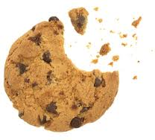
Cookie Erosion

 | Q-Tip | Toothpick | Water
Hypothesis |  |  | 1 minutes
 |  |  | 5 minutes
Results |  |  | 1 minutes
 |  |  | 5 minutes

Erosion: The Great Race
Question: Water, wind, or glacial—which type of erosion causes the biggest changes?
Hypothesis:

Observations:
Tray A: | Tray B: | Tray C:
1. | 1. | 1.
2. | 2. | 2.
3. | 3. | 3.
4. | 4. | 4.
Conclusion:

Erosion
Directions: Describe the three types of erosion by drawing or writing what happens during each type.
Before:
___________ Erosion
___________ Erosion
___________ Erosion
After:

Glaciers in Motion

Name: Katelyn Rosevear Time Allotted: 20 minutes
Grade Level: 3rd Subject: Science
Materials Required:
- Sticky Notes
- Glacier Match pictures (one set of pictures per student)
- Changes from Glaciers (one worksheet per student)
- Pencils
- Crayons

Michigan Content Expectations
E.SE.03.22 Identify and describe natural cause of change in the Earth’s surface (erosion, glaciers, volcanoes, landslides, and earthquakes)

CCSS.ELA-Literacy.W.3.2 Write informative/explanatory texts to examine a topic and convey ideas and information clearly.

Objective(s):
The student will identify natural causes of change in the Earth’s surface, such as, glaciers by scoring at least 5 out of 6 on the “Glacier Match” activity. (Knowledge)

The student will describe the natural causes of change in the Earth’s surface made by glaciers by scoring a 3 or higher on the content portion of the rubric for the “Changes from Glaciers” worksheet. (Comprehension)

Student Friendly Objectives:

The student will identify natural causes of change in the Earth’s surface, such as, glaciers. (Knowledge)

The student will describe the natural causes of change in the Earth’s surface made by glaciers. (Comprehension)

I can write an informative paragraph on glaciers impact on Michigan. (Application)

Assessment:

Objective 1 Assessment:
After learning the definition of a glacier, students will participate in a “glacier match” activity, which will assess their ability to indentify glaciers. Each student will have a set of pictures, which they will sort into two groups- glaciers and not glaciers. Students who do not meet the minimum level of proficiency should review the slide on “What is a Glacier?” then resort the pictures. (Formal Summative)

Objective 2 Assessment:
Think-pair-share. As students share questions regarding glaciers, the teacher listening to see that students are asking relevant questions. (Informal Formative)

Objective 2 Assessment:
At the end of the lesson, each student will complete a “Changes from Glaciers” worksheet. This will assess the students’ capability to describe the changes made by glaciers. On the top half of the sheet, students will draw a picture of a glacier and on the bottom portion of the worksheet, students will write a paragraph describing the kinds of change made by glaciers (specifically, what kinds of change glaciers have made in Michigan). If a student has not mastered this concept, they will be given a chance to review the “how glaciers move” information. They can also do some guided research on these websites: http://www.onegeology.org/extra/kids/earthprocesses/glaciers.html and http://www.kidskonnect.com/subjectindex/15-educational/science/81-glaciers.html. (Formal Formative)

Objective 3 Assessment:
On the “Changes from Glaciers” worksheet, students will use informative writing to describe the changes made by glaciers. The student should provide a minimum of two facts or examples to support their writing. (Formal Formative)

Objective 3 Assessment:
On the unit test (question 12) students will write an informative paragraph, informing the reading how glaciers change the earth’s surface. (Formal Summative)

Objective 1 and 2 Assessment:
Unit test- students will score an 80% or higher on the test to show they have reached the learning targets. (Formal Summative)
Instructional Procedure:

Anticipatory Set:
  - Slowly reveal a picture of a glacier, piece by piece. Have students try to identity what is in the picture- It’s a glacier!
  - Remember how we learned about erosion? Can anyone tell me what erosion means? Erosion is “the breaking up and moving of weathered rocks from one place to another” (Badders, 2000). For example, the Grand Canyon was created by erosion.
  - Today we are going to learn about glaciers and how they can cause changes to the Earth through erosion.
  - Before we can continue in our lesson, I need your full attention. Remember to keep your eyes and ears on me, listen carefully to directions, and try your very hardest. Are we ready to begin?
State Purpose and Objective of Lesson:
  - Read the student friendly objectives together as a class. Post the objectives in the front of the classroom.
  - Much of Michigan’s landscape was formed through glaciers. In order for you to better understanding of land formations in Michigan, you need to have an understanding of what glaciers are and what they can do.
Instructional Input/Direct Instruction:
  - Provide students with a definition of what a glacier is. “Glaciers are large ice masses that form over land. Glaciers are constantly, slowly moving (Badders, 2000).
When a chunk of ice breaks off a glacier and into the sea, it is call an iceberg.”
  - Model the “Glacier Match” activity then lead the class in guided practice.
Students complete the “Glacier Match” activity.
  - ask class to generate questions that they may have about glaciers, based on what they know of glaciers. “What are some questions we can ask about glaciers to help us better understand what glaciers are and what they do?”
TSW think of researchable questions regarding glaciers that they would like to find the answer to then sort the questions as researchable or testable. Next they will watch a video on glaciers http://www.youtube.com/watch?feature=player_embedded&v=tM3x6_vb8_s.
  - Ask student to hypothesis how glaciers form. After a few hypotheses are made, explain how glaciers form (give students guided notes to help them later recall information for the “Changes from Glaciers” worksheet) . “Have you ever had a snowball fight and made a snow ball that turned into ice? This is due to the pressure put on the snow ball. In order for a glacier to form it must be very cold. When a glacier forms the first thing to happen is snowfall. Next another layer of snow falls and the snow accumulates. This continues until the snow is very deep with many layers. Pressure from the weight of the top layers of snow presses on bottom layers, turning them to ice. Just like pressing on a snowball will cause it to turn to ice. Glaciers can take many years to form. There are two kinds of glaciers. Glaciers that form between two mountains are called valley glaciers and large million acre glaciers are called continental glaciers or ice caps (Grigg, 2001).”
  - Students hypothesize how glaciers move.
Explain how glaciers move. “Once a glacier forms, it will begin to slowly move. The weight of the glacier causes it to slowly creep down the mountains or across a plain. The movement of the glacier changes the surface it moves along. As the glacier moves it scrapes against the surface and picks up crushed rocks and other sediment. This is a form of erosion. The movement of glaciers creates grooves in the underlying rock. When parts of the glacier later melt, they may leave behind some of these materials collected along the glacier’s path. Glaciers are important to the formation of Michigan. Thousands of years ago, much of North America was covered in a continental glacier (Grigg, 2011). The Great Lakes were formed by glacier movement, which carved the lakes out of the surface of the land. Also many Michigan lakes were formed from pieces of glaciers that broke off and were buried in the ground. Once the land thawed, lakes formed in those places (Fuhrman, n.d.)”
  - “Use informative writing to describe how glaciers have changed the Earth’s surface in Michigan. Informative writing uses facts or examples to support your ideas.” Model/explain the use of informative writing on the “Changes from Glaciers” worksheet then lead the class in guided practice.
Students complete the “Changes from Glaciers” worksheet.
Modeling:
  - Before students do the Glacier Match, the teacher shows a couple examples while explaining why the picture would or would not qualify as a glacier.
  - “In this picture, I can see many layers of snow and ice. Also I see that is formed over land. This means that it is a glacier. In the next picture, I again see layers of snow and ice, but it is not over land- it is in the middle of the ocean. So this is not a glacier.”
  - Before students complete the “Changes from Glaciers” worksheet, the teacher will give an example of how to fill out the worksheet.
Guided Practice:
  - As a class, practice identifying glaciers so students are prepared to finish the Glacier Match on their own.
  - Before the students complete the “Changes from Glaciers” worksheet, the class will break into small groups. In the groups they will discuss a few ways they have learned that glaciers create change in the Earth’s surface.
  - As a whole class, have groups share one fact they learned. Teacher should correct any false information, before allowing students to move on to the worksheet on their own.
Independent Practice:
- After the class practices identifying glaciers, the students will do the Glacier Match on their own.
- Students will complete the “Changes from Glaciers” worksheet independently, using their guided notes to help them.
- When you go home, share with your family what you have learned about glaciers. You still have some unanswered questions about glaciers. Your homework is to use your research skills and try to find the answer to your question.

Differentiated Consideration (Adjust instruction, tools, resources or activities for students who):
- Students who finish their work early can watch an additional video on glaciers. http://www.youtube.com/watch?feature=player_embedded&v=tM3x6_vb8_s#
Or students can hypothesize what the landscape of Michigan would be like if glaciers had not effected it.
- Students who are struggling in with the “Glacier Match” can work with a partner. Students who are having difficulty writing the paragraph for the worksheet can dictate their writing to either a teacher or a student who has finished early.
Multiple Intelligences:
Logical-mathematical: Students are developing a hypothesis for how glaciers move.
Spatial: Students are drawing a picture of a glacier and sorting pictures of glaciers.
Linguistic: Students are writing a paragraph describing the ways glaciers affect the Earth’s surface and taking notes throughout the lesson.
Bodily-kinesthetic: Students can create motions to help them remember how a glacier moves.
Intrapersonal: Students are pair-sharing their definition of a glacier.

Closure:
  - Today we have learned how to identify a glacier and we have also discovered how a glacier creates natural change in the surface of the Earth.
  - Show me, which picture is a glacier. (Hold up one finger for the first picture, two fingers for the second, and three fingers for the third.) Tell me how a glacier creates change in the Earth’s surface.
  - We do not see glaciers in Michigan any more but they are found in other parts of the world. Continue to be an explorer and see if you can find where glaciers are located today.

References:

Badders, W., Peck, D., Bethel, L. J., Sumners, C., Fu, V., & Valentina, C. (2000). Houghton Mifflin science discovery works. Boston: Houghton Mifflin.
Fuhrman, J. (n.d.). Lessons on photosynthesis and Michigan glacial history. Retrieved from http://teachingphotosynthesisandglaciers.weebly.com /teaching-geology--glaciers.html
Grigg, C. (2011). What are glaciers? Retrieved from http://www.edhelper.com/ ReadingComprehension_54_1796.html

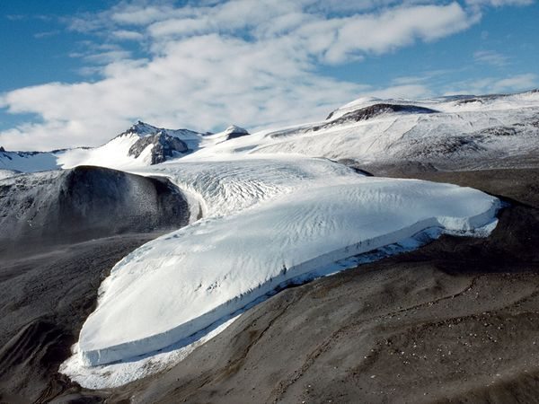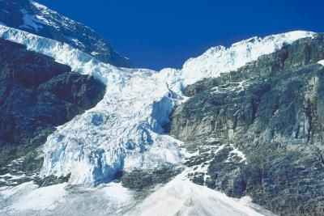

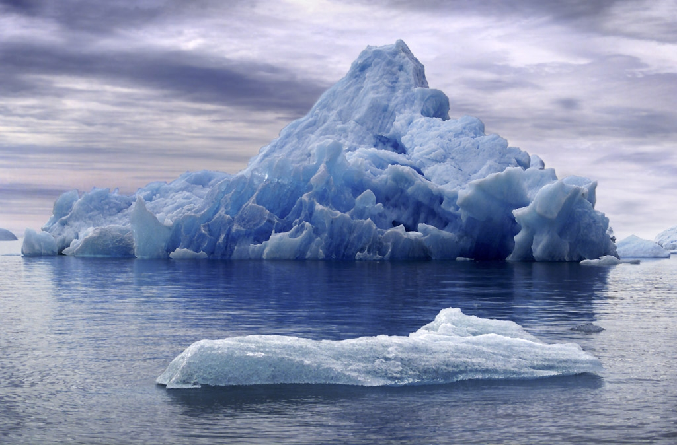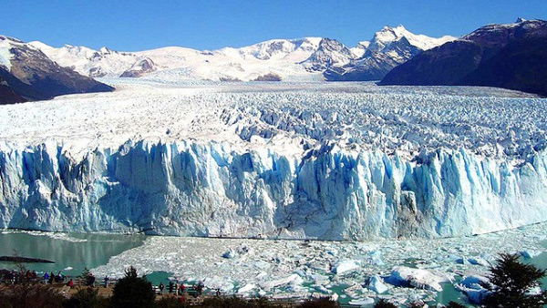
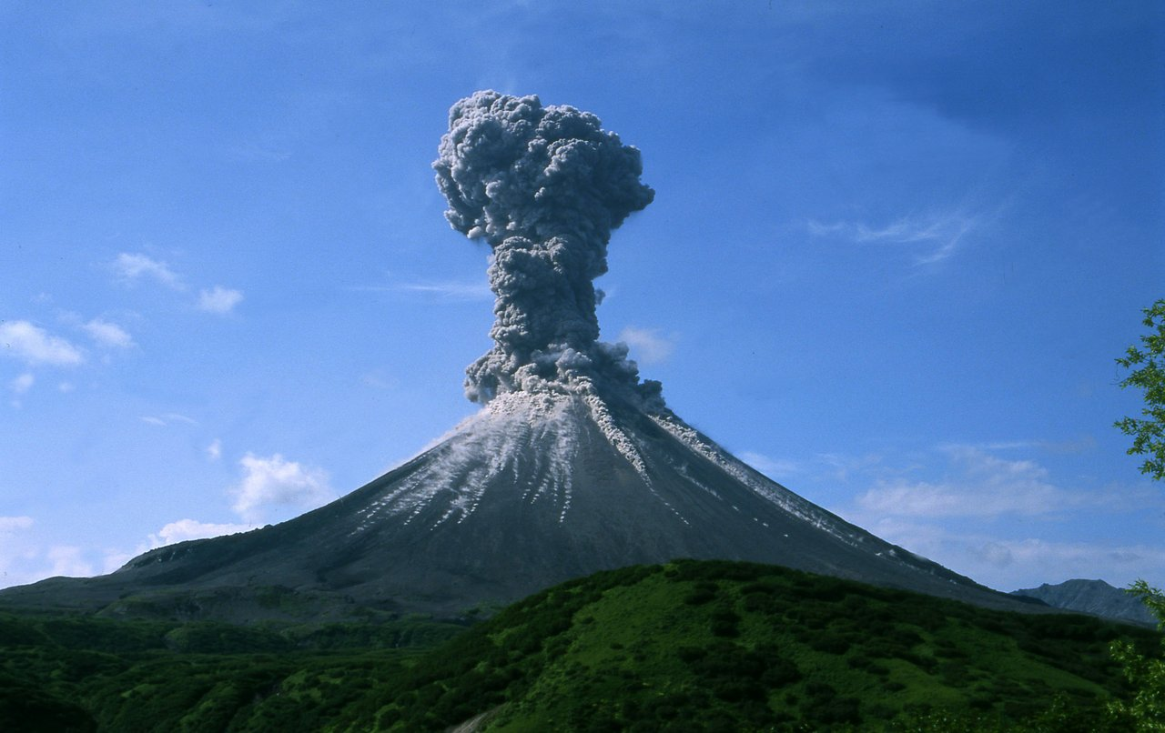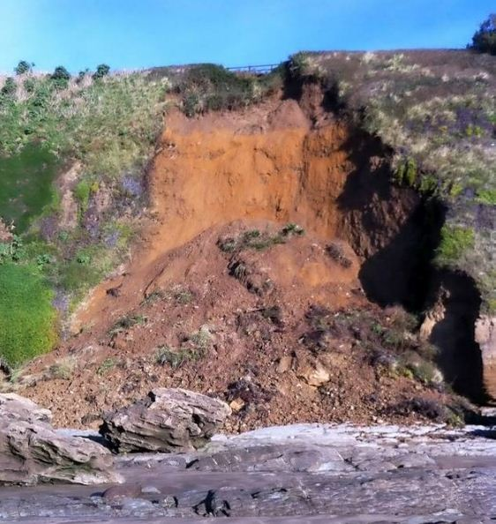
Glacier
Not a Glacier

How Do Glaciers Form?
- For a glacier to form the temperature must be ________.
- First __________ must fall.
- More snow falls and forms a new __________ of snow.
- Pressure form the weight of the _______ layer of snow presses on the bottom layers, turning them to _______.
- There are two kinds of glaciers _______________________ formed between two mountains and _______________________ which can be millions of acres in size.

How Do Glaciers Move?
- The _________ of the glacier causes it to __________ move.
- As the glacier moves it ______________ against the surface it moves along.
- Along the way the glacier picks up ____________ and other sediment.
- This is a form of ________________________.
- The movement creates _______________ in the underlying rock.
- When the glacier ____________, it may leave behind some of the materials it has collected.
- ____________ of years ago, North America was covered by a _________________ glacier.
- The ____________________________ were formed by glacier movement, which ___________ the lakes out of the surface of the land.
- Many Michigan lakes were formed from pieces of glaciers that broke off and were _________ buried in the ground. Once the land ____________, lakes formed in those places.
Name:______________________ Date:_______________________
Changes from Glaciers

Draw a picture of a glacier in the box.

Write a paragraph describing how glaciers create a change in the Earth’s surface. Include at least one example of how glaciers have impacted Michigan.
________________________________________________________________________________________________________________________________________________________________________________________________________________________________________________________________________________________________________________________________________________________________________________________________________________________________________________________________________________________________________________________________________________________________________________________________________________________________________________________________________

